# Travel

You need to add 25 things to this document. (Make sure to number them just as I did in the example.) It may be helpful to copy and paste this list and then fill it in as you go along. All image names must start with your location, e.g yellowstone_sunset.jpg unless you are using a link from the internet.

## Bangkok

1. Primary Image of Location as a gif



1. Primary Image of Location as non-gif.

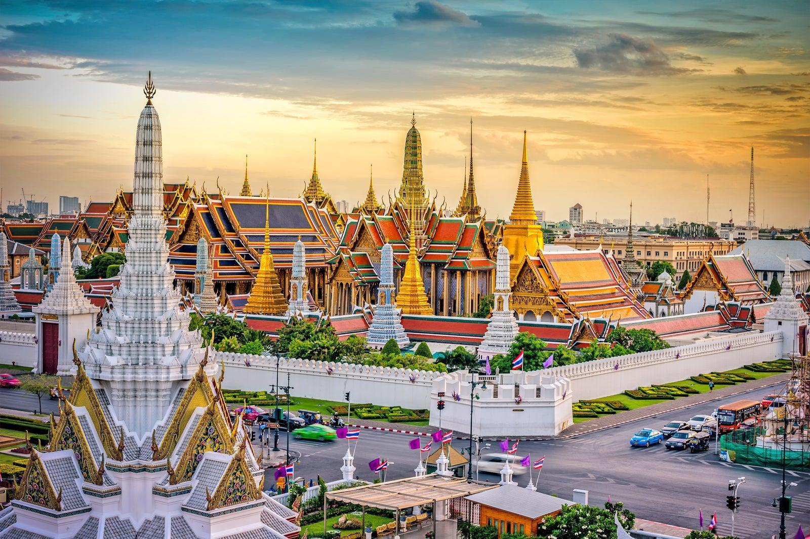

1. Name of file with gif file (make sure to add the picture to the proper Google Drive!)

bangkok_gif.gif

1. Name of file with non gif file (make sure to add the picture to the proper Google Drive!)

bangkok-nongif.jpeg

1. **Geographical Location**: Southeast Asia
2. Bangkok, Thailand’s capital, is a large city known for ornate shrines and vibrant street life. It is officially known in [Thai](https://en.wikipedia.org/wiki/Thai_language) as Krung Thep Maha Nakhon and colloquially as Krung Thep.
3. Bangkok welcomes more visitors than any other city in the world and it doesn’t take long to realize why. Bangkok is a city of contrasts with action at every turn. Marvel at the gleaming temples, catch a tuk tuk through bustling Chinatown or take a longtail boat through floating markets. Food is another Bangkok highlight, from local dishes served at humble street stalls to haute cuisine at romantic rooftop restaurants.

For the next five pictures you can just put the names of the files, you don't have to include the files in this drive, but you do need to add them to the [proper Google Drive](https://drive.google.com/drive/folders/1sroWta5PKm63E3V2KWSUE-uYkPd_v6T5?usp=sharing).

1. **Photo Gallery – (Just write Photo Gallery)**
2. khlong _lat_mayom.jpeg
3. Khlong Lat Mayom water market
4. Khlong Lat Mayom, one of the best floating markets in Bangkok.It is most famous for its food. Try snakehead fish and the shrimps.
5. grand_palace.jpeg
6. White houses with golden top
7. The Grand Palace is a complex of buildings at the heart of Bangkok.
8. khao_san_road.jpeg
9. Busy street of daytime khao san road
10. Khao San road, which now represents a series of streets, is a place in downtown Bangkok where backpackers and tourists are immediately drawn to from when they first touch down in the airport.
11. wat_arun.jpg
12. Wat Arun temple
13. Wat Arun is one of the most popular and well-known places of worship. Famous for its iridescent glow when first light hits its porcelain finish at dawn, it also resembles an ancient city at first glance.
14. Jinjin Cai

## Yellowstone National Park

1. **Photo Gallery**
2. yellowstone_travertine.JPG
3. A large mound of multi-colored travertine
4. Mammoth Hot Springs has a number of actively forming Travertine terraces.
5. yellowstone_sunset.jpg
6. Sunset over mountains with some charred trees in the foreground
7. The drive to Lamar Valley requires some dangerous roads. But the result is amazing sunset views.
8. yellowstone_prism.MOV
9. N/A
10. The multicolored layers get their hues from different species of bacteria living in the cooler water around the spring.
11. yellowstone_buffalo.MOV
12. N/A
13. The buffalo were so common along the roads in Yellowstone that our mantra became "If it ain't lickin the car, we aren't stopping."
14. yellowstone_sulphur_springs.JPG
15. A large spring with clouds of sulfur smoke rising from it.
16. If you can handle the odor, the Yellowstone Sulphur Springs is a great place to hike.
17. Colleen van Lent